|  |  |
| --- | --- |
| EGC_Black | **MATHEMATICS METHODS UNIT 3 & 4**  **TEST 5 2016**  **Calculator Free** |

Name: \_\_\_\_\_\_\_\_\_\_\_\_\_\_\_\_\_\_\_\_\_\_\_\_\_\_\_\_\_

Reading Time: 2 minutes

Total Marks: 22 marks Time Allowed: 22 minutes

**Question One: [2, 3 = 5 marks]**

Consider the probability density function drawn below:

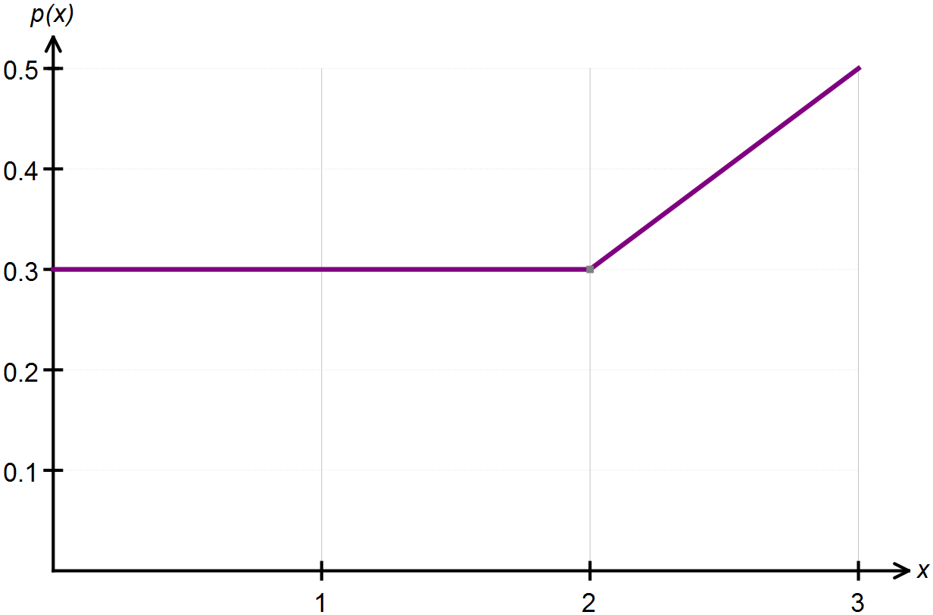

(a) Confirm, with appropriate calculations, that this above graph represents a probability density function.

(b) State the piecewise function that defines this continuous random variable.

**Question Two: [3 marks]**

Determine the value(s) of *k* which makes the following function a probability density

function.



**Question Three: [4 marks]**

On a recent test, Tom scored 70% and his standard score was 1. Jerry sat the same test and his standard score was -0.5 when he scored 55%.

Calculate the mean and standard deviation for these test results.

**Question Four: [2, 2, 2, 2, 2 = 10 marks]**

The heights of fairy penguins in a particular geographic location are normally distributed with a mean height of 32 cm and a standard deviation of 1.5 cm.

Use the 68%, 95% and 99.7% rule to calculate each of the following.

(a) Determine the probability that a randomly selected fairy penguin is taller than 30.5 cm.

(b) Determine the probability of a randomly selected fairy penguin being shorter than 30.5 cm if it is known that they are in the 0.5 quantile.

(c) In a sample of 2000 penguins, how many would you expect to be taller than 35cm?

(d) What is the maximum height of the shortest 2.5% of penguins in this location?

(e) In a different geographic location the mean height of the fairy penguins found there is 33 cm. If 97.5% of the penguins are shorter than 35cm, and their heights are also normally distributed, what is the standard deviation for this population?

|  |  |
| --- | --- |
| EGC_Black | **MATHEMATICS METHODS UNIT 3 & 4**  **TEST 5 2016**  **Calculator Assumed** |

Name: \_\_\_\_\_\_\_\_\_\_\_\_\_\_\_\_\_\_\_\_\_\_\_\_\_\_\_\_\_

Reading Time: 3 minutes

Total Marks: 44 marks Time Allowed: 45 minutes

**Question Five: [2, 1, 1, 2, 3 = 9 marks]**

According to the Apple support site, the time taken to download a 2 hour movie using an ADSL2+ Broadband connection is uniformly distributed between 18 and 24 minutes. Let T be the time taken to download one 2 hour movie from the Apple store.

(a) Sketch the probability distribution function for T.

(b) Calculate the mean time taken to download a movie.

(c) 75% of the time it takes less than *k* minutes to download a movie. Calculate the value of *k.*

(d) Calculate 

(e) This week, Dom has downloaded one movie each day. Determine the probability that exactly three of them took more than 22 minutes to download.

**Question Six: [1, 1, 2, 1 = 5 marks]**

A random variable *X* is normally distributed with a mean of 40 cm and a standard deviation of 3 cm.

(a) Calculate the value of *x* associated with a standardised score of  .

(b) Determine the value of the 85th percentile.

(c) Calculate  .

(d) Determine *k* for  .

**Question Seven: [1, 1, 3, 1, 3, 1, 2, 1, 1, 2 =16 marks]**

During December, a local shopping centre has a gift wrapping stall which is open 12 hours a day. On average, the gift wrapping stall serves 120 customers per day.

(a) What is the average length of time between serving each customer at this gift wrapping stall? Give your answer in minutes.

This scenario can be best modelled by an exponential probability density function which is given by  where  is the mean time between serving customers.

(b) Hence state the probability density function for X, where X represents the time between serving each customer.

(c) Show, using calculus methods, that your answer to part (b) does in fact represent a continuous probability density function.

(d) State the expected value of the distribution.

(e) Show, using calculus methods, that the standard deviation of the distribution is the same as the mean.

(f) If the time between serving customers was instead recorded in hours, determine the new mean and standard deviation of the distribution.

(g) Calculate the median waiting time, in minutes, between customers.

Calculate the probability that the next customer will be served:

(h) less than 5 minutes after the previous one.

(i) between 5 and 7 minutes after the previous one.

(j) less than 8 minutes after the previous one given that it took longer than 5 minutes.

**Question Eight: [3 marks]**

In a state spelling competition, results were normally distributed with a mean of 58% and a standard deviation of 14%.

Participants who scored between 85% and 95% received a certificate of distinction. In the state, 103 participants were awarded a certificate of distinction.

How many students participated?

**Question Nine: [2, 3, 3, 3 = 11 marks]**

To apply to be an international flight attendant for QANTAS, your height must be between 163 cm and 183 cm.

Data collected in 2011 indicates that the mean height of adult males in Australia is 175.6 cm. The mean height of adult females in Australia is 161.8 cm with a standard deviation of 3.8 cm. Both the heights of the males and females are normally distributed.

(a) Out of a random sample of 2000 Australian adult female applicants, how many would you expect to meet the QANTAS height requirements?

(b) The proportion of adult male Australian applicants who are below the maximum height requirement is 0.96096. Calculate the standard deviation for the height of the applicants.

(c) An applicant is 170 cm tall. Are they more likely to be a tall female or a short male?

(d) QANTAS are interviewing potential applicants, all of whom meet the height requirement. The first three interviewees are female. What is the probability that the first two are less than 168 cm and the third is taller than 165 cm?